Community Base
113 Queens Road
Brighton
BN1 3XG

t: 01273 234839
e: info@mindout.org.uk

Company Number 7441667
Charity Number 1140098

August 2020
Dear Applicant,

Thank you for your interest in the Trans Advocacy Worker post with MindOut.
Enclosed with the application pack are:
- a job description
- a person specification
- background information about the project
- an application form
If you would like this information in another format, e.g. large print or in audio format please let us know.

The post is for 21 hours per week, is confirmed until 30th June 2022 and is a permanent contract subject to on-going funding. The hours can be worked flexibly by arrangement and will involve occasional evenings and weekends. The post holder will be based in our office at Community Base, 113 Queens Road, Brighton and/or working from home due to the Covid-19 pandemic. All applicants must be able to travel to the office to work. We are looking for a trans identified applicant.

The salary for this post is £24,313 pro rata (£14,588 pa). MindOut provides up to 5% of salary contribution to pension scheme, depending on employee contribution. The post holder is entitled to 29 days leave per year pro rata, excluding Bank Holidays.

Applications will be judged according to the criteria of the job description and person specification as required by our Equality, Diversity and Inclusion Policy and Recruitment Policy. Please make sure you answer every point in the person specification on your application form, paying attention to essential criteria. All successful applicants are subject to an enhanced DBS check. This post is subject to a probationary period of 6 months.

Please return your application form to myself at the above address. I regret we are unable to accept late applications. The closing date for applications is 5pm on Thursday 27th August and interviews will be held via Zoom on Friday 4th September.

Yours sincerely,

Jason Saw
Service Manager

MindOut

Lesbian, Gay, Bisexual, Transgender and Queer Mental Health Service

Job Description

Job Title Trans Advocacy Worker

Responsible to Advocacy Senior Practitioner

Summary of Duties
- to provide case work advocacy for trans and non-binary clients
- to promote and develop self-advocacy, peer advocacy and group advocacy initiatives for trans and non-binary people
- to support MindOut’s other services

Main Tasks

Advocacy
- liaise with individual service users to determine their needs for support, guidance, representation and information around issues relating to trans and non-binary identities, trans care pathways and any other issues related to trans and non-binary lives
- provide general information on trans and non-binary related issues, legal rights, primary care and mental health service policy and procedures
- support service users in self-advocacy, expressing opinions, concerns and complaints about their care and treatment
- to ensure service users are aware of their options and support them to make informed decisions
- to manage an advocacy caseload and ensure service users are kept informed and up to date on any work being carried out on their behalf
- accompany or represent service users at decision making meetings, including clinical assessments
- to work to agreed case work standards, recording, referral, monitoring and evaluation systems
- maintain strict confidentiality with regard to information given by and information about service users
- liaise closely with line management around case management and allocation
- to provide outreach to minority LGBTQ communities to help ensure the service is accessible

Advocacy Related
- to promote and uphold the principles of advocacy standards
- monitor issues of general concern in the delivery and quality of services and contribute to MindOut’s policy and developmental role
- liaise with statutory and voluntary sector service providers on issues which arise from the course of the work
- to develop partnership working around issues of collective concern in trans communities, to liaise closely with Healthwatch
- provide information and advice on legal and rights issues to other professionals
- contribute to service development, quality assurance and staff training on advocacy and related issues
- maintain links with service user groups and other bodies as appropriate, to ensure that advocacy development remains centred on service users’ perceived needs
- to maintain awareness of advocacy and trans related issues and developments on a national basis

General Responsibilities
- attend as appropriate meetings with the Director, staff team and MindOut executive and sub committees
- prepare regular reports as required by the Director, MindOut committees or the project funder
- carry out other such tasks as appropriate in negotiation with line management that may be reasonably expected
- carry out all responsibilities with regard to MindOut’s Equality, Diversity and Inclusion and Anti-discrimination Policy and all other policies
- to participate in relevant training and self development
- the post holder will be responsible for undertaking their own administration

This job description will be reviewed periodically with the post holder to take account of changing demands.

PERSON SPECIFICATION
See below the experience, skills, knowledge and competencies required to carry out the tasks described within the job description. Please ensure that you use examples to demonstrate how you meet each individual criterion on your application form. Criteria marked ‘A’ will be used to shortlist candidates and criteria marked ‘I’ will be assessed during the interview stage. Criteria marked E are Essential to the role, D are desirable for the role.

No. |  | Assessment  Process | Essential/  Desirable
 | Experience
1 | Personal understanding and broad experience of trans and non-binary issues. | A & I | E
2 | Experience of working within the health and social care field. | A&I | E
3 | Experience and understanding of mental health issues. Personal experience will be viewed positively. | A&I | E
4 | Experience of an affirmative approach to LGBTQ mental health issues | A & I | E
5 | Experience of case work management and advocacy representation, including trans and non-binary related support | A & I | D
6 | Experience of working within an advocacy principled framework and to the standards set out by the Advocacy Quality Performance Mark | A&I | D
 | Skills
7 | Demonstrable ability to advocate on the behalf of others. I.e. good negotiation and problem solving skills. | A & I | E
8 | Ability to prioritise and organise own caseload and maintain up to date records of work undertaken. | A & I | E
9 | Ability to engage with vulnerable adults and people in distress, including suicidal distress | A & I | E
10 | Ability to establish and maintain effective relationships with professionals and partners across varying disciplines. | A&I | E
11 | Written and oral communication is concise and accurate. Ability to prepare and provide written and verbal reports. | A & I | E
12 | Ability to work flexibly as part of a team and on your own initiative. | A&I | E
 | Knowledge
13 | Knowledge and understanding of trans care pathways, related services, research and legislation. | A&I | E
14 | Understanding of and demonstrable commitment to coproduction and service user engagement and participation. | A & I | E
15 | Understanding of and demonstrable commitment to equal opportunities and understanding of diversity within LGBTQ communities | A & I | E
16 | Accredited training in advocacy, e.g. National Advocacy Qualification | A&I | D

MindOut Recruitment information August 2020
Who we are

MindOut is run by and for LGBTQ people with experience of mental health issues. Our services are impartial, independent, non-judgmental and confidential. Service user participation is key in all aspects of planning, delivery and governance of the organisation and its services.

Our Vision is a world where the mental health of LGBTQ communities is a priority, free from stigma, respected and recognised.

Our Mission is to improve the wellbeing of LGBTQ people who experience mental health issues, reduce mental health stigma, and promote positive mental health amongst LGBTQ communities.

Our aims are to:
- improve mental wellbeing for LGBTQ people
- reduce social isolation in LGBTQ communities
- reduce suicidal distress in LGBTQ communities
- reduce stigma associated with mental health
- improve mental health services for LGBTQ people

Our values and principles are:
- MindOut is run by and for LGBTQ people with lived experience of mental health issues
- wellbeing includes all aspects of mental, physical and emotional health, across the whole range of mental health issues
- LGBTQ mental health is a collective concern for LGBTQ communities
- we work to promote equality and the diversity of our communities and the principle of accessible and safe spaces
- our work is co-produced by service users, volunteers and staff; this applies to research, development, design, promotion and delivery
- service users are engaged at all levels of the organisation and supported to volunteer, apply for paid work and become Trustees
- we work to continuously improve all we do
- we invest in our workforce

Our services include:
- advice and information
- mental health advocacy, including urgent need advocacy
- trans specific advocacy
- peer support group work
- peer mentoring and befriending
- a low cost counselling service
- on-line support
- wellbeing courses and workshops
- suicide prevention initiatives, including Out of the Blue peer support group
- social groups and outings
- LGBTQ affirmative practice training and trans awareness training

MindOut’s History

MindOut is 20 years old. For the first 12 years, MindOut was a project within Mind in Brighton and Hove. From 1st April 2011 MindOut became an independent organisation, a charity and a company limited by guarantee.

Staff Team

The MindOut staff team consists of the Chief Executive, Deputy Chief Executive, Service Manager, Advocacy Senior Practitioner, Peer Support Senior Practitioner, Counselling Coordinator, three Advocacy Workers, Suicide Prevention Worker, Online support worker, Business Development Manager, two Administrators and one Group Worker. See structure diagram below.

Volunteer Teams

Currently MindOut has approx. 50 volunteers working on the Counselling, Peer Mentoring, telephone befriending, online and group work services.

Board of Trustees

MindOut’s Executive Committee has 12 Trustees, led by our Chair, Dominic Arnall.

Organisational Structure

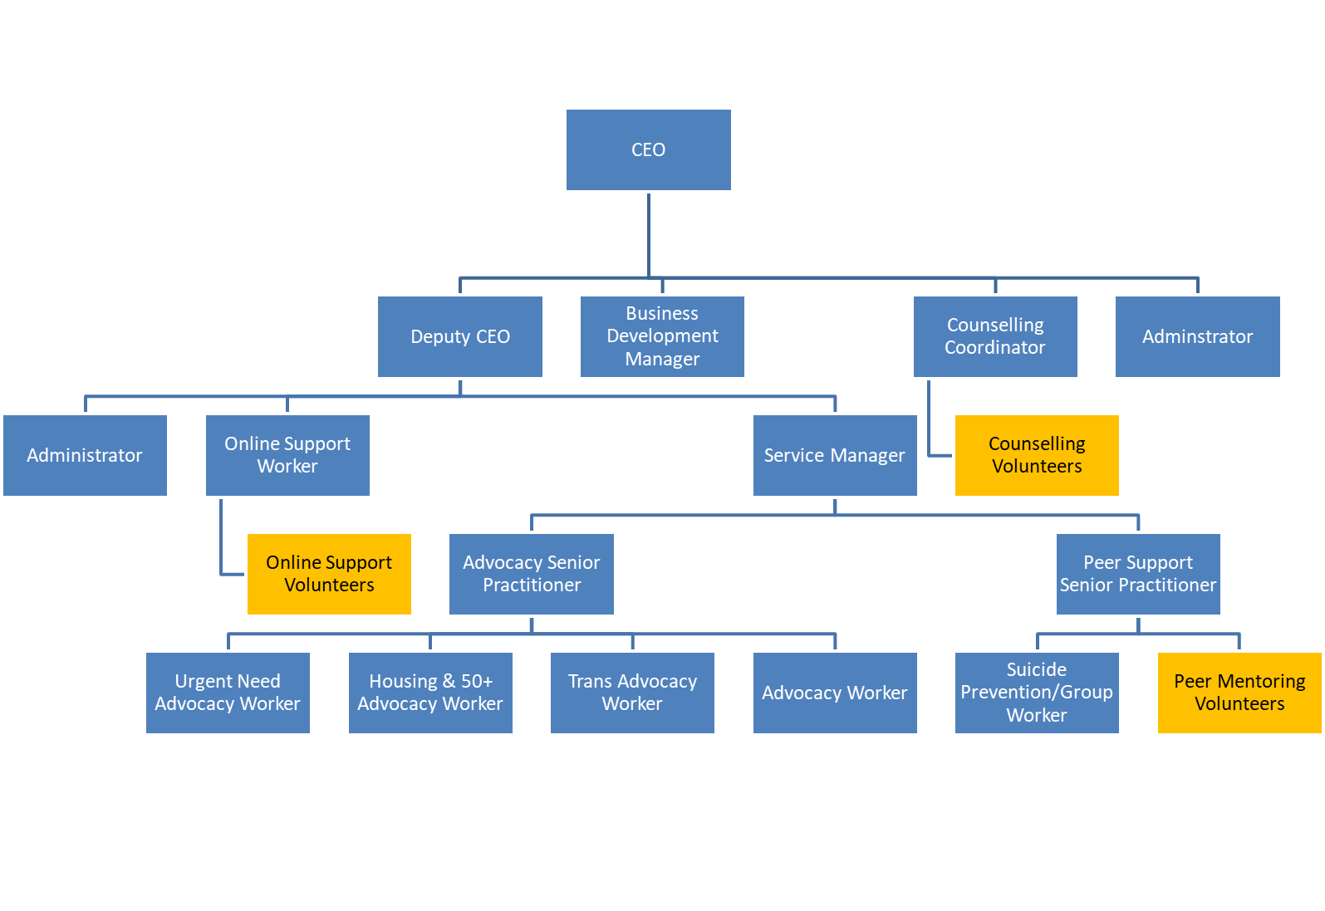

Please complete in type or black ink

Application for the appointment of: | Trans Advocacy Worker

PERSONAL DETAILS (IN BLOCK CAPITAL LETTERS)

SURNAME & TITLE |  |  |  |  |  |  |  | ADDRESS
Preferred Pronoun
FIRST NAME
TEL Home: |  |  |  |  | Work: |  |  |  | Mobile:
Email
If you are currently employed, may we contact you discreetly at work? |  |  |  |  |  |  |  |  |  |  | Yes/No

EDUCATION AND TRAINING

Please give details of your educational qualifications and experience including short courses where appropriate. Please continue on additional sheets if you need to expand this section.
Venue | Date | Courses/Qualifications

EMPLOYMENT HISTORY (INCLUDING VOLUNTARY WORK)

List in date order with present or most recent first
Please continue on additional sheets if you need to expand this section.

Name and Address of Employer | Job title and brief description of responsibilities | From | To | Reasons for leaving

If you are currently employed, please state your notice period:

GAPS IN EDUCATION/EMPLOYMENT HISTORY

If you have any gaps of 6 months or more in your education/employment history, please let us know in the following table. Please continue on additional sheets if you need to expand this section.

From | To | Reasons for gap

KNOWLEDGE, SKILLS AND EXPERIENCE RELEVANT TO THE POST

This is the most important part of the form. The person specification lists the knowledge and skills you need to do the job. These will not necessarily be gained through paid employment. They can also be gained through voluntary work and life experience. If you do not meet all the criteria it is unlikely that you will be short listed for interview.
When completing this section it is useful to use the criteria listed in the person specification as headings and under these please give examples by referring to your professional, academic, personal life or voluntary work. Use extra sheets if you need to and make sure they are clearly marked with your name and the title of the job for which you are applying.
Knowledge, skills and experience relevant to the post: Statement

Knowledge, skills and experience relevant to the post (continuation)

I confirm that to the best of my knowledge the information given on this form is true and correct and can be treated as part of any subsequent contract of employment.

Signature |  | Date:

REFERENCES

Please give details of two people to whom we can apply for references concerning your suitability for this post. One of these should be your current or most recent employer. Please note we DO NOT accept friends or family members as referees. If you do not wish us to contact either referee before informing you, please make this clear. Any offer of employment will be subject to satisfactory references.
Name: |  |  | Name:
Job Title: |  |  | Job Title:
In what capacity do you know them? |  |  | In what capacity do you know them?
Address: |  |  | Address:
Post code: |  |  | Post code:
Telephone: |  |  | Telephone:
E-mail: |  |  | E-mail
Can we contact before interview? |  |  | Can we contact before interview?

APPLICANTS WITH DISABILITIES
MindOut LGBTQ Mental Health Service is committed to employing people with disabilities. Please state any arrangements we can make to assist you, if called for interview or appointed to the post:

Disciplinary /Criminal Record
MindOut undertakes not to discriminate unfairly against any subject of a Disclosure on the basis of conviction or other information revealed.
Disciplinary: Have you ever been the subject of disciplinary action in the past? No Yes
If Yes, please give details below
Date | Employer | Subject | Outcome

Convictions: Have you ever been cautioned by the police or convicted of a criminal offence? No Yes

Have you ever been referred to the children’s or adult’s ‘barred’ list? No Yes

If Yes to either question, please give details on a separate sheet. Note, this should exclude any spent convictions under Section 4(2) of the Rehabilitation of Offenders Act 1974, unless the job for which you are applying involves working directly with vulnerable adults, in which case both spent and unspent convictions cautions, bind overs and pending prosecutions must be declared.

PRIVACY NOTICE
MindOut needs to keep and process information about you for the purposes of considering your job application.

This includes information enabling us to consider your suitability for the role; in order to comply with any legal requirements; to pursue the Legitimate Interests of the Charity and to protect our legal position in the event of legal proceedings.

The sort of information we hold includes your contact details; your application form and references; correspondence with or about you; and your performance in any interview(s), if offered.

Much of the information we hold will have been provided by you, but some may come from other sources, such as interviewers and referees.

We may process special categories of information, including (but not limited to) your racial or ethnic origin, political opinions, religious and philosophical beliefs, trade union membership, biometric data or sexual orientation. Our handling of this data will be subject to our Equal Opportunities in Employment policy, and will be done on the Legal Basis of Legitimate Interest on condition of Article 9(2):b; j of the GDPR.

We may also process data about criminal offences. Our handling if this data will be done on the Legal Basis of Legitimate Interest on condition of Article 10 of the GDPR, consistent with applicable Employment Law.

We will keep data relating to your application for up to one year. This is to allow us time to process your application, including if the same or a similar post is re-recruited and you wish to apply; to fulfil our Equal Opportunities in Employment policy; and to protect our legal position in the event of legal proceedings.

You have various rights considering your data under the relevant legislation, including the right to be informed; the right of access; the right to rectification; the right to erase; the right to restrict processing; the right to data portability; the right to object; rights in relation to automated decision making and profiling. For more information about your rights, please contact us and/or consult the Information Commissioner's Office.

THIS SECTION WILL BE DETACHED AND WILL NOT BE SEEN BY THE SELECTION PANEL. IT WILL BE USED ONLY FOR MONITORING PURPOSES

EQUAL OPPORTUNITIES IN EMPLOYMENT – STATEMENT OF POLICY
MindOut LGBTQ Mental Health Service is an equal opportunities employer and will apply objective criteria to assess merit. MindOut aims to ensure that no job applicant or employee receives less favourable treatment on the grounds of nationality, religion, ethnicity, gender, gender expression, marital status, pregnancy or maternity, sexual orientation, age or disability or is disadvantaged by conditions or requirements which cannot be shown to be justifiable. MindOut is particularly concerned not to discriminate against applicants who have lived experience of mental health issues.
Selection criteria and procedures will be reviewed frequently to ensure that individuals are selected, promoted and treated on the basis of their relevant merits and abilities. All employees will be given equal opportunity and where appropriate and possible, special training to enable them to progress within and outside the organisation. MindOut is committed to a programme of action to make this policy fully effective.
Would you please provide the following information which will be treated as confidential but which will assist us to monitor and implement our Equal Opportunities Policy. Your application will not be affected by the information provided or if you choose not to complete part or all of this section.

APPLICATION FOR THE POST OF:

Please state here where you saw the post advertised

DOB:

How would you describe your gender?
Female |  | Male |  | Non-binary |  |  | Queer
Unsure |  | Other – please state:

Do you or have you ever identified as transgender? |  | Yes |  | No

How would you describe your sexual orientation?

Bisexual |  | Gay |  | Heterosexual |  |  | Lesbian |  | Queer
Other – please state:

Which category best describes your ethnic or cultural origin?

Asian |  | Mixed |  | White
Asian British |  | Asian & White |  | British
Bangladeshi |  | Black African & White |  | Irish
Indian |  | Black Caribbean & White |  | European
Pakistani |  | Other |  | Other
Other
Black |  | Chinese or Other Ethnic Group
Black British |  | Chinese |  | Gypsy
African |  | Arab |  | Traveller
Caribbean |  | Jewish |  | Other
Sudanese

If you have a religious or other belief how would you describe it?

Agnostic |  | Christian |  | Jewish |  | Sikh
Atheist |  | Hindu |  | Muslim |  | Other
Buddhist |  | Jain |  | Pagan
Other belief:

Are your day to day activities limited because of a health problem or disability which has lasted, or is expected to last, at least 12 months?

Yes a little |  | Yes a lot |  | No (don’t answer next question)
If you answered yes, please state the type of impairment. If you have more than one, please indicate all that apply. If none apply, please mark “other” and write an answer in (examples given as guidance)

Developmental condition |  | Mental health condition |  |  | Physical impairment
Learning disability/difficulty |  | Long standing illness |  |  | Other (please sate)

