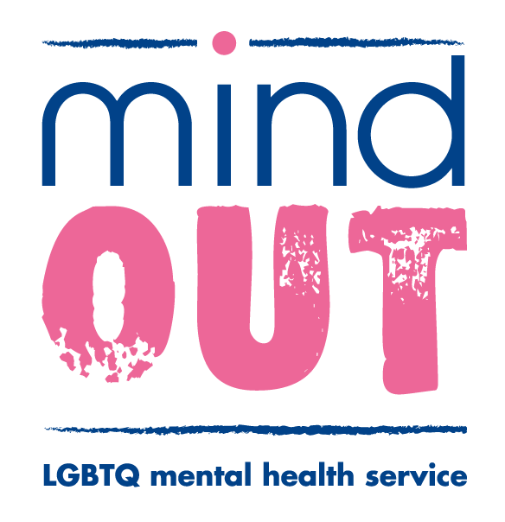
Please return this form to:
MindOut Counselling Service
Community Base
113 Queens Road
Brighton
BN1 3XG

Or email it to: george.tidey@mindout.org.uk

MindOut LGBTQ Mental Health Project
Relationship Counselling Application Form

Please ensure that each person applying for relationship counselling completes an application form. Relationship counselling requires committing to attending all sessions together. It is worth talking about this together before you apply.

Client code: ----/------ (for office use only)

Your Name: --------------------------------------------------

Preferred pro noun: --------------------------------------------------

Your partners name and pro noun:------------------------------------------

Your Address: -------------------------------------------------------------------------------------------

--------------------------------------------------------------------------------------------------------------

-------------------------------------------Postcode: ------------------------------Age: ----------------

Email address--------------------------------------------------------

Contact Number ----------------------------------------------------

What is the best way of contacting you?-------------------------------------------------------

Is it Ok to leave a message on your phone? Yes No

Do you have any cultural and/or spiritual requirements you would like us to know about?

--------------------------------------------------------------------------------------------------------------
We appreciate that this form may take some time to complete. However, considering and answering the following questions will help both you and your counsellor to start thinking about whether relationship counselling at MindOut is the best option for you and your partner at this time.

This is a confidential service and all applications for counselling are only viewed by those involved in processing applications. Your personal details are only shared with the service coordinator and the counsellor involved.

The next stage in your request for counselling is that you and your partner will be invited for an initial assessment to explore further with a counsellor how counselling may be of help to you both. There will also be an opportunity to discuss the cost of your sessions which will be based on you and your partner’s gross annual income.

What brings you to relationship counselling and why now?

------------------------------------------------------------------------------------------------------------------------------------------------------------------------------------------------------------------------------------------------------------------------------------------------------------------------------------------------------------------------------------------------------
______________________________________________________________________________

How long have you been having these difficulties in your relationship?
------------------------------------------------------------------------------------------------------------------------------------------------------------------------------------------------------------------------------------------------------------------------------------------------------------------------------------------------------------------------------------------------------
______________________________________________________________________________

How do you and your partner deal with conflict and anger in your relationship?

------------------------------------------------------------------------------------------------------------------------------------------------------------------------------------------------------------------------------------------------------------------------------------------------------------------------------------------------------------------------------------------------------
______________________________________________________________________________

Has there ever been or is there currently physical violence between you and your partner?

--------------------------------------------------------------------------------------------------------------------------------------------------------------------------------------------------------------------------------------------------------------------
--------------------------------------------------------------------------------------------------------------------------------------------------------------------------------------------------------------------------------------------------------------------

What do you hope to gain from relationship counselling for yourself and your relationship?

------------------------------------------------------------------------------------------------------------------------------------------------------------------------------------------------------------------------------------------------------------------------------------------------------------------------------------------------------------------------------------------------------
______________________________________________________________________________

Do you currently receive any professional help/support from any other mental health professional, for example another counsellor/therapist, psychologist, psychiatrist, CPN, etc? Please give details.
----------------------------------------------------------------------------------------------------------------------------------------------------------------------------------------------------------------------------------------------------------------------------------------------------------------------------------------------------------------------------------------------------------------------------------------------------------------------------------------------------------------------------------------

Are you currently receiving any treatment or medication for any physical or mental health conditions? Please give details.
--------------------------------------------------------------------------------------------------------------------------------------------------------------------------------------------------------------------------------------------------------------------------------------------------------------------------------------------------------------------------------------------------------------------------------------------------------------------------------------------------------------------------------------------------------------------------------------------------------------------------------------------------------------------------

If we have serious concerns about your or someone else’s wellbeing or you have a medical emergency we may need to contact your G.P

GPs details:

Name: ------------------------------------------------------------------------------------------------------

Address:-----------------------------------------------------------------------------------------------------------------------------------------------------------------------------------------------------------------

Telephone:-----------------------------------------------------------------------------------------------

Who would you like us to contact in an emergency (This needs to be someone other than your partner who will be joining you in counselling)

Name:------------------------------------------------------------------------------------------------------

Relationship:----------------------------------------------------------------------------------------------

Emergency contact phone number: ______________________________________

Have you ever had individual or relationship counselling before? (Please circle)

Yes No

If yes, how would you describe that experience?
--------------------------------------------------------------------------------------------------------------------------------------------------------------------------------------------------------------------------------------------------------------------------------------------------------------------------------------------------------------------------------------------------------------------------------------------------------------------------------------------------------------------------------------------------------------------------------------------------------------------------------------------------------------------------

Who are the most significant/supportive people in your life?
----------------------------------------------------------------------------------------------------------------------------------------------------------------------------------------------------------------------------------------------------------------------------------------------------------------------------------------------------------------------------------------------------------------------------------------------------------------------------------------------------------------------------------------

Counselling sessions are offered at a regular time and day once per week. Are you and your partner able to commit to this for a period of 6-12 weeks? (Please explain if this is difficult, for example if you work shifts.)

The relationship counselling service operates a sliding scale fee dependent on you and your partner’s gross annual income. Please let us know your gross annual income here so that we can let you know how much you will need to pay for your counselling sessions:

----------------------------------------------------------------------------------------------------------------

All of our counsellors are volunteers and most work at specific times. If your availability is restricted there may be a delay in allocating you a counsellor whose availability matches yours.

Please tell us the days and times that you and your partner are available to see a counsellor.

Monday Morning Afternoon Evening

Tuesday Morning Afternoon Evening

Wednesday Morning Afternoon Evening

Thursday Morning Afternoon Evening

Friday Morning Afternoon Evening

Saturday Morning Afternoon

MindOut counsellors all identify as Lesbian, Gay, Bisexual, Transgender and/or Queer and are either fully qualified or working towards a recognised counselling qualification.

If you and your partner have any specific requirement that needs to be considered when allocating you a counsellor please write this below, otherwise leave this space blank.

----------------------------------------------------------------------------------------------------------------------------------

Please tell us below if you need wheelchair access.

Please let us know if you have any communication or information needs, for example requiring a translator, information in braille or large print, sign language interpreter etc.
----------------------------------------------------------------------------------------------------------------------------------

How did you find out about the MindOut relationship counselling service?

----------------------------------------------------------------------------------------------------------------

Equality and Diversity
Monitoring Form
MindOut needs the information you give to provide data on who benefits from our services. If there are any questions that you do not want to answer, please do leave them blank. The information you give is confidential.

How would you describe your gender?
Female Male Gender Queer Queer Unsure Other……………...

Do you now, or have you ever considered yourself transgender?
Yes No

How would you describe your sexual orientation?
Bisexual Gay Lesbian Heterosexual/straight Queer Unsure Other…………..

If you have a postcode please write it here ________________

How would you describe your ethnic origin?
Asian or Asian British Black or Black British White
Bangladeshi African British/English/Scottish/ Northern Irish/Welsh
Chinese Caribbean Irish
Indian Sudanese European
Thai Other…………………. Gypsy
Pakistani Traveller
Other…………………. Any other white background………………….

Other Ethnic Group Mixed
Turkish Asian & White
Arab Asian & Black African
Japanese Asian & Black Caribbean
Jewish Black Caribbean & White
Any other ethnic group Black African and White
Other mixed background…………….

If you have a religious or other belief how would you describe it?
Agnostic Christian Jewish Sikh
Atheist Hindu Muslim Other
Buddhist Jain Pagan Other belief……………………

What is your date of birth? _____/______/____

Do you have any communication or information needs, for example related to disability or sensory loss? Yes No

Are your day-to-day activities limited because of a health problem or disability which has lasted, or is expected to last, at least 12 months?
Yes a little Yes a lot No (do not answer the next question)

If you answered yes, please state the type of impairment. If you have more than one, please indicate all that apply. If none apply, please mark ‘other’ and write an answer in. (examples are given as guidance)
Developmental Condition Mental Health Condition Physical Impairment
Learning Disability/Difficulty Long-standing Illness Other (please state)

Are you a carer? If yes, do you care for a….?
Yes Child with special needs Parent
No Partner/ spouse Other Family Member
Friend Other (please give details)

