Community Base
113 Queens Road
Brighton
BN1 3XG

t: 01273 234839
e: info@mindout.org.uk

reg. company no. 7441667
Charity Number 1140098

January 2019
Dear Applicant,

Thank you for your interest in the post of Deputy CEO at MindOut.

Enclosed with the application pack are:
- a job description
- a person specification
- background information about MindOut
- an application form

If you would like this information in another format, e.g. large print or audio, please let us know.

The post is for 21 hours per week to be worked over 3 days, including occasional evening and weekend work. The post is funded initially for 12 months. The post holder will be based in our office at Community Base in central Brighton. The salary is £34,500 pro rata (£20,700 pa) paid monthly in arrears. Holiday entitlement is 29 days a year pro rata, excluding Bank Holidays. MindOut provides a 5% contribution to a group pension scheme to match employee contribution. The post is subject to a probationary period of 6 months. Appointment is subject to an enhanced DBS check.

Applications will be judged according to the criteria of the job description and person specification as required by our Equality, Diversity & Inclusion and Recruitment Policies. Please make sure you answer every point in the person specification on your application form.

Please return your application form to myself at the above address. I regret we are unable to accept late applications. The closing date for applications is 5pm on Wednesday 30th January and interviews will be held on Wednesday 13th February.

Yours sincerely,
Helen Jones
CEO
Deputy CEO

This is a new role to deputise for our founder CEO, Helen Jones. Working closely with the CEO, Trustee Board and Senior Management Team, you will be responsible for internal operations, quality assurance, the development and embedding of new initiatives, for monitoring, evaluation and reporting to funders. You will play a key role in the strategic development and growth of the organisation, including stakeholder management and developing partnerships.

Initially funded for 12 months, we hope to continue to fund the post subject to review.

MindOut LGBTQ Mental Health Service

JOB DESCRIPTION
Deputy CEO

Responsible to: CEO

Responsible for: Service Manager
Counselling Coordinator
Admin Team

Job Summary
The role is part of the senior management team, working with the CEO on the strategic and operational development of MindOut. The post is responsible for line management as above and for the delivery, monitoring, evaluation and development of the organisation’s services.

The role has responsibility for quality assurance, human resource systems and for key strategic partnerships.

Main Duties

Strategic development
- To work with the CEO, Board of Trustees, stakeholders, funders, partners and service users to develop MindOut’s strategic vision and development plans
- To identify opportunities for innovation and service development and contribute to business planning

Service Delivery, Quality Assurance, Monitoring and Evaluation
- To be responsible for the delivery of MindOut’s services in line with our values, mission, strategic plan, policies and procedures
- To ensure that all services meet quality standards, including the Advocacy Quality Performance Mark
- To oversee data collection and performance monitoring systems, ensuring services are meeting KPIs and targets, and prepare reports to funders and the Board of Trustees
- To oversee risk management of MindOut service delivery
- To ensure that all services are co-produced with service users

Leadership and Management
- To work closely with the CEO to ensure a consistent approach to leading and managing staff and volunteers
- To be responsible for line management of Service Manager, Counselling Coordinator and Administrators including supervision and performance management
- To oversee staff learning, development and training
- To oversee health and safety for employees and for service delivery, including risk assessment, management cover and service continuity
- To ensure that human resource systems are regularly reviewed and are administered fairly

Resource Management
- To work with the CEO to set and manage the annual budget, cash flow and financial projections
- To oversee the setting of service budgets ensuring that they are competitive and realistic
- To monitor the financial performance of services, in conjunction with service leads
- To prepare business cases for service development and restructuring

Relationship Management

- To be responsible for developing effective, professional relationships with commissioners, funders, partners and LGBTQ community representatives
- To develop professional relationships with staff, volunteers, service users, Trustees and management colleagues
- To represent MindOut at key local and national external meetings and events

Service Development
- To oversee the improvement and ongoing development of MindOut’s services
- To develop MindOut’s co-production policies and procedures, adhering to best practice
- To identify development and new service opportunities, with the involvement of service users, in line with MindOut’s strategic and business plans
- To work closely with the CEO and Business Development Manager on tender submissions and funding applications
Organisational Responsibilities
- To deputise in the absence of the CEO and contribute to the wider management of MindOut, taking a key leadership role internally and externally
- To contribute to the governance of MindOut, leading on regular review of policies and procedures, liaising with the CEO and Board of Trustees
- To work in accordance with MindOut’s values, mission and strategic plan
- To promote the work of MindOut and positive understanding, awareness and attitudes towards mental health
- To work flexibly to best meet the needs of the service which may include undertaking occasional evening and weekend work

This list of duties and responsibilities is not intended to be exhaustive. The post holder will be expected to take on additional tasks as required by the CEO or Board of Trustees in keeping with the general profile of the role.
Person Specification
Outlined below are the experience, skills, knowledge and competencies required to carry out the tasks described within the job description. Please ensure that you use examples to demonstrate that you meet each individual criterion on your application form.

Essential criteria

Experience
1. Experience of leading service delivery at a senior level in public or third sector organisation in health and/or social care, including setting up and closing down services
2. Personal understanding and experience of lesbian, gay, bisexual, trans and queer issues.
3. Experience of an affirmative approach to LGBTQ mental health service delivery.
4. Experience of managing contracts, service level agreements and grants.
5. Experience of working closely with a CEO and Chair of Trustees.
6. Experience of developing effective performance management systems.
7. Experience of creating and developing strategic and business plans.
8. Experience of effective financial management through budget setting, service development and performance monitoring processes.
9. Proven track record of winning new business through competitive tenders and other funding proposals, including developing partnerships to win funding.
10. Experience of achieving and maintaining quality standards and/or external quality marks.

Skills
11. Strong financial and HR management skills.
12. Ability to develop and maintain professional, effective strategic partnerships.
13. Ability to motivate, lead and manage front line managers.
14. Strong bid and report writing skills.
15. The ability to communicate effectively with a wide range of stakeholders, including presentation skills.
16. Good working knowledge of MS Office.

Knowledge/Qualification
17. Knowledge of safeguarding legislation and best practice.
18. Knowledge and understanding of charity finance and governance.
19. Knowledge of the relevant policy and commissioning context and external environment.
20. A good understanding of the importance of confidentiality, the principles of data protection and GDPR requirements.
21. Educated to degree level and/or relevant management qualification.

Personal Contribution
22. Commitment to and understanding of MindOut’s aims and objectives.
23. Committed and reliable member of team and understands impact of role within the organisation.
24. Takes responsibility for organising own work effectively and for delivering results.
25. Ability to work independently taking initiative and a solution focused approach.
26. Committed to own personal and professional development, aspires to CEO position in the future.

Desirable criteria
26. Experience and knowledge of charity governance.

MindOut Recruitment information January 2019
Who we are

MindOut is run by and for LGBTQ people with experience of mental health issues. Our services are impartial, independent, non-judgmental, confidential and person-centred. Service user participation is key in all aspects of planning, delivery and governance of the organisation and its services.

Our Vision is a world where the mental health of LGBTQ communities is a priority, free from stigma, respected and recognised.

Our Mission is to improve the wellbeing of LGBTQ people who experience mental health issues, reduce mental health stigma, and promote positive mental health amongst LGBTQ communities.

Our aims are to:
- improve mental wellbeing for LGBTQ people
- reduce social isolation in LGBTQ communities
- reduce suicidal distress in LGBTQ communities
- reduce stigma associated with mental health
- improve mental health services for LGBTQ people

Our values and principles are:
- MindOut is run by and for LGBTQ people with lived experience of mental health issues
- wellbeing includes all aspects of mental, physical and emotional health, across the whole range of mental health issues
- LGBTQ mental health is a collective concern for LGBTQ communities
- we work to promote equality and the diversity of our communities and the principle of accessible and safe spaces
- our work is co-produced by service users, volunteers and staff; this applies to research, development, design, promotion and delivery
- service users are engaged at all levels of the organisation and supported to volunteer, apply for paid work and become Trustees
- we work to continuously improve all we do
- we invest in our workforce

Our services include:
- advice and information
- mental health advocacy, including urgent need advocacy
- trans specific advocacy
- peer support group work
- peer mentoring
- a low cost counselling service
- on-line support
- wellbeing courses and workshops
- suicide prevention initiatives, including Out of the Blue peer support group
- social groups and outings
- LGBTQ affirmative practice training and trans awareness training
MindOut’s History

For the first 12 years, MindOut was a project within Mind in Brighton and Hove. From 1st April 2011 MindOut became an independent organisation, a charity and a company limited by guarantee. We moved to offices at Community Base.

Staff Team

The MindOut staff team consists of the Chief Executive, Service Manager, Advocacy Senior Practitioner, Peer Support Senior Practitioner, Counselling Coordinator, three Advocacy Workers, Suicide Prevention Worker, Business Development Manager, two Administrators and two Group Workers working between 5 and 7 hours per week. See structure diagram below.

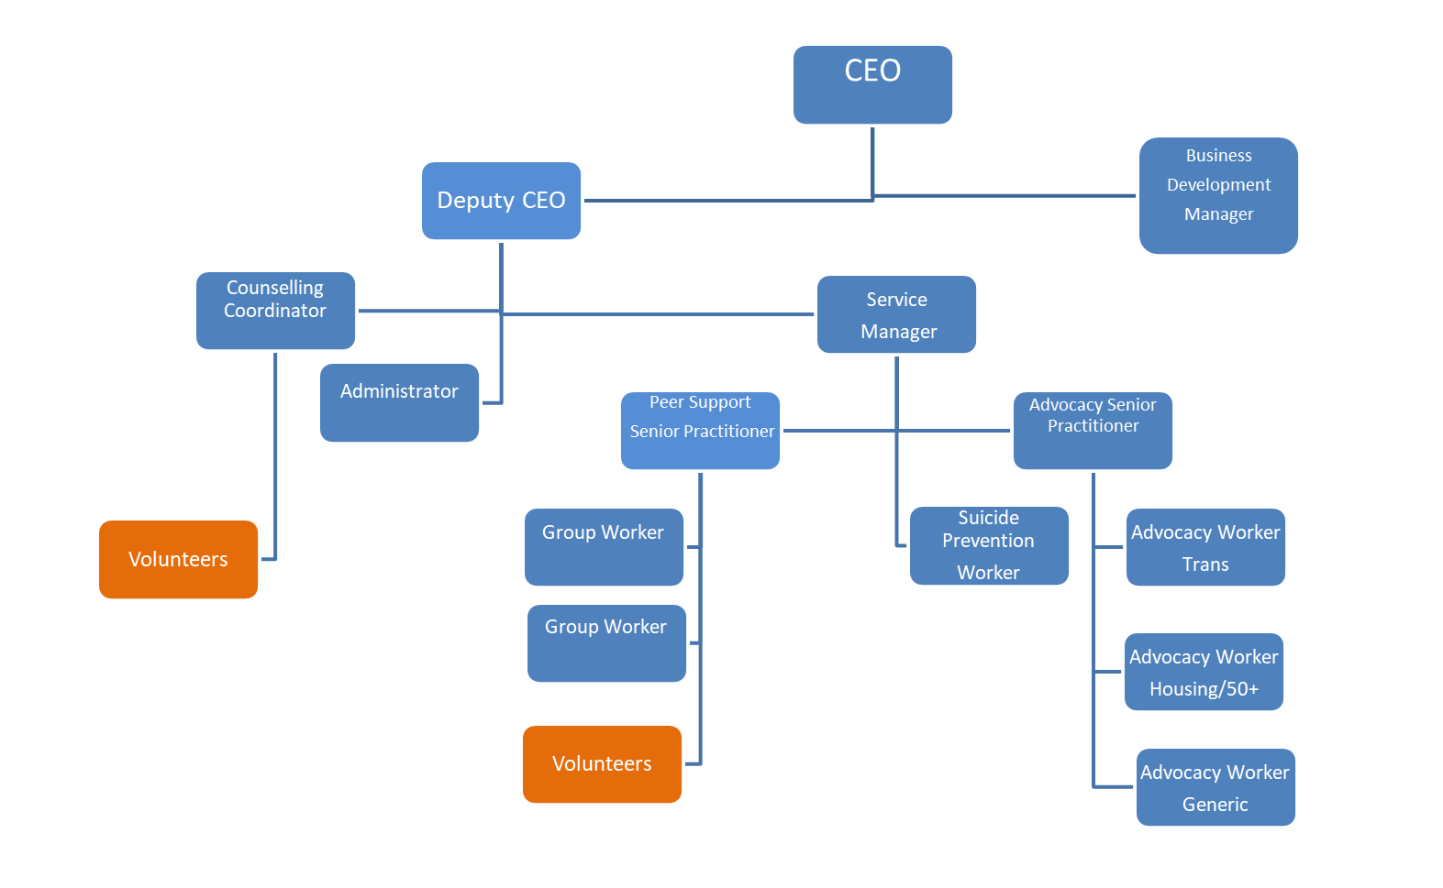

Volunteer Teams

Currently MindOut has approx. 50 volunteers working on the Counselling, Peer Mentoring, online and group work services.

Board of Trustees

MindOut’s Executive Committee has 6 Trustees, led by our Chair, Alison France.

Please complete in type or black ink

Application for the appointment of: | Deputy Chief Executive

PERSONAL DETAILS (IN BLOCK CAPITAL LETTERS)

SURNAME & TITLE |  |  |  |  |  |  |  | ADDRESS
Preferred Pronoun
FIRST NAME
TEL Home: |  |  |  |  | Work: |  |  |  | Mobile:
Email
If you are currently employed, may we contact you discreetly at work? |  |  |  |  |  |  |  |  |  |  | Yes/No

EDUCATION AND TRAINING

Please give details of your educational qualifications and experience including short courses where appropriate. Please continue on additional sheets if you need to expand this section.
Venue | Date | Courses/Qualifications

EMPLOYMENT HISTORY (INCLUDING VOLUNTARY WORK)

List in date order with present or most recent first
Please continue on additional sheets if you need to expand this section.

Name and Address of Employer | Job title and brief description of responsibilities | From | To | Reasons for leaving

If you are currently employed, please state your notice period:

GAPS IN EDUCATION/EMPLOYMENT HISTORY

If you have any gaps of 6 months or more in your education/employment history, please let us know in the following table. Please continue on additional sheets if you need to expand this section.
From | To | Reasons for gap

KNOWLEDGE, SKILLS AND EXPERIENCE RELEVANT TO THE POST

This is the most important part of the form. The person specification lists the knowledge and skills you need to do the job. These will not necessarily be gained through paid employment. They can also be gained through voluntary work and life experience. If you do not meet all the criteria it is unlikely that you will be short listed for interview.
When completing this section it is useful to use the criteria listed in the person specification as headings and under these please give examples by referring to your professional, academic, personal life or voluntary work. Use extra sheets if you need to and make sure they are clearly marked with your name and the title of the job for which you are applying.
Knowledge, skills and experience relevant to the post: Statement

Knowledge, skills and experience relevant to the post (continuation)

I confirm that to the best of my knowledge the information given on this form is true and correct and can be treated as part of any subsequent contract of employment.

Signature |  | Date:

REFERENCES

Please give details of two people to whom we can apply for references concerning your suitability for this post. One of these should be your current or most recent employer. Please note we DO NOT accept friends or family members as referees. If you do not wish us to contact either referee before informing you, please make this clear. Any offer of employment will be subject to satisfactory references.
Name: |  |  | Name:
Job Title: |  |  | Job Title:
In what capacity do you know them? |  |  | In what capacity do you know them?
Address: |  |  | Address:
Post code: |  |  | Post code:
Telephone: |  |  | Telephone:
E-mail: |  |  | E-mail
Can we contact before interview? |  |  | Can we contact before interview?

APPLICANTS WITH DISABILITIES
MindOut LGBTQ Mental Health Service is committed to employing people with disabilities. Please state any arrangements we can make to assist you, if called for interview or appointed to the post:

Disciplinary /Criminal Record
MindOut undertakes not to discriminate unfairly against any subject of a Disclosure on the basis of conviction or other information revealed.
Disciplinary: Have you ever been the subject of disciplinary action in the past? No Yes
If Yes, please give details below
Date | Employer | Subject | Outcome

Convictions: Have you ever been cautioned by the police or convicted of a criminal offence? No Yes

Have you ever been referred to the children’s or adult’s ‘barred’ list? No Yes

If Yes to either question, please give details on a separate sheet. Note, this should exclude any spent convictions under Section 4(2) of the Rehabilitation of Offenders Act 1974, unless the job for which you are applying involves working directly with vulnerable adults, in which case both spent and unspent convictions cautions, bind overs and pending prosecutions must be declared.

PRIVACY NOTICE
MindOut needs to keep and process information about you for the purposes of considering your job application.

This includes information enabling us to consider your suitability for the role; in order to comply with any legal requirements; to pursue the Legitimate Interests of the Charity and to protect our legal position in the event of legal proceedings.

The sort of information we hold includes your contact details; your application form and references; correspondence with or about you; and your performance in any interview(s), if offered.

Much of the information we hold will have been provided by you, but some may come from other sources, such as interviewers and referees.

We may process special categories of information, including (but not limited to) your racial or ethnic origin, political opinions, religious and philosophical beliefs, trade union membership, biometric data or sexual orientation. Our handling of this data will be subject to our Equal Opportunities in Employment policy, and will be done on the Legal Basis of Legitimate Interest on condition of Article 9(2):b; j of the GDPR.

We may also process data about criminal offences. Our handling if this data will be done on the Legal Basis of Legitimate Interest on condition of Article 10 of the GDPR, consistent with applicable Employment Law.

We will keep data relating to your application for up to one year. This is to allow us time to process your application, including if the same or a similar post is re-recruited and you wish to apply; to fulfil our Equal Opportunities in Employment policy; and to protect our legal position in the event of legal proceedings.

You have various rights considering your data under the relevant legislation, including the right to be informed; the right of access; the right to rectification; the right to erase; the right to restrict processing; the right to data portability; the right to object; rights in relation to automated decision making and profiling. For more information about your rights, please contact us and/or consult the Information Commissioner's Office.

THIS SECTION WILL BE DETACHED AND WILL NOT BE SEEN BY THE SELECTION PANEL. IT WILL BE USED ONLY FOR MONITORING PURPOSES

EQUAL OPPORTUNITIES IN EMPLOYMENT – STATEMENT OF POLICY
MindOut LGBTQ Mental Health Service is an equal opportunities employer and will apply objective criteria to assess merit. MindOut aims to ensure that no job applicant or employee receives less favourable treatment on the grounds of nationality, religion, ethnicity, gender, gender expression, marital status, pregnancy or maternity, sexual orientation, age or disability or is disadvantaged by conditions or requirements which cannot be shown to be justifiable. MindOut is particularly concerned not to discriminate against applicants who have lived experience of mental health issues.
Selection criteria and procedures will be reviewed frequently to ensure that individuals are selected, promoted and treated on the basis of their relevant merits and abilities. All employees will be given equal opportunity and where appropriate and possible, special training to enable them to progress within and outside the organisation. MindOut is committed to a programme of action to make this policy fully effective.
Would you please provide the following information which will be treated as confidential but which will assist us to monitor and implement our Equal Opportunities Policy. Your application will not be affected by the information provided or if you choose not to complete part or all of this section.

APPLICATION FOR THE POST OF:

Please state here where you saw the post advertised

DOB:

How would you describe your gender?
Female |  | Male |  | Non-binary |  |  | Queer
Unsure |  | Other – please state:

Do you or have you ever identified as transgender? |  | Yes |  | No

How would you describe your sexual orientation?

Bisexual |  | Gay |  | Heterosexual |  |  | Lesbian |  | Queer
Other – please state:

Which category best describes your ethnic or cultural origin?

Asian |  | Mixed |  | White
Asian British |  | Asian & White |  | British
Bangladeshi |  | Black African & White |  | Irish
Indian |  | Black Caribbean & White |  | European
Pakistani |  | Other |  | Other
Other
Black |  | Chinese or Other Ethnic Group
Black British |  | Chinese |  | Gypsy
African |  | Arab |  | Traveller
Caribbean |  | Jewish |  | Other
Sudanese

If you have a religious or other belief how would you describe it?

Agnostic |  | Christian |  | Jewish |  | Sikh
Atheist |  | Hindu |  | Muslim |  | Other
Buddhist |  | Jain |  | Pagan
Other belief:

Are your day to day activities limited because of a health problem or disability which has lasted, or is expected to last, at least 12 months?

Yes a little |  | Yes a lot |  | No (don’t answer next question)
If you answered yes, please state the type of impairment. If you have more than one, please indicate all that apply. If none apply, please mark “other” and write an answer in (examples given as guidance)

Developmental condition |  | Mental health condition |  |  | Physical impairment
Learning disability/difficulty |  | Long standing illness |  |  | Other (please sate)

