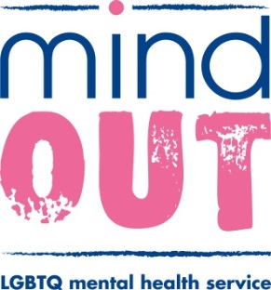
Advocacy Enquiry Form
MindOut’s Lesbian, Gay, Bi, Trans and Queer mental health advocacy service is run by and for LGBTQ people and is free, confidential, non-judgemental and independent from other services and professionals.

A MindOut advocate can:
- listen to any concerns you have about your mental health or wellbeing
- talk with you about any issues related to your LGBTQ identity
- help you to have your voice heard on issues that are important to you
- help you to defend and safeguard your rights
- help you to have your views and wishes considered when decisions are being made about your life

To speak to one of our advocates, please let us know:
Your name………………………………………………………………………………..
Your preferred pronoun…………………………………………………………………
Your contact details …………………………………………………………………….
………………………………………………………………………………………
Have you used the MindOut Advocacy service before? Yes/No
Please send this form by email to: info@mindout.org.uk or directly to one of our advocates:
Emma Crossland, Urgent Need Advocate
Emma.crossland@mindout.org.uk

Phil Brooke, Mental Health Advocate
Phil.brooke@mindout.org.uk

Maeve Devine, Trans Advocate
Maeve.devine@mindout.org.uk

If you prefer, you can print and post this form to MindOut, Community Base, 113 Queens Road, Brighton. BN1 3XG
You can also get in touch with an advocate: by telephone 01273 234 839 or via our out of ours online support service through our website www.mindout.org.uk

